**ASSIGNMENT 3**

1. write a SQL query to find Employees who have the biggest salary in their Department

select d.dept_name,e.emp_name,e.salary from dept d

join emp e

on e.dept_id = d.dept_id

and e.salary = (select max(salary) from emp e where e.dept_id = d.dept_id)

order by salary desc

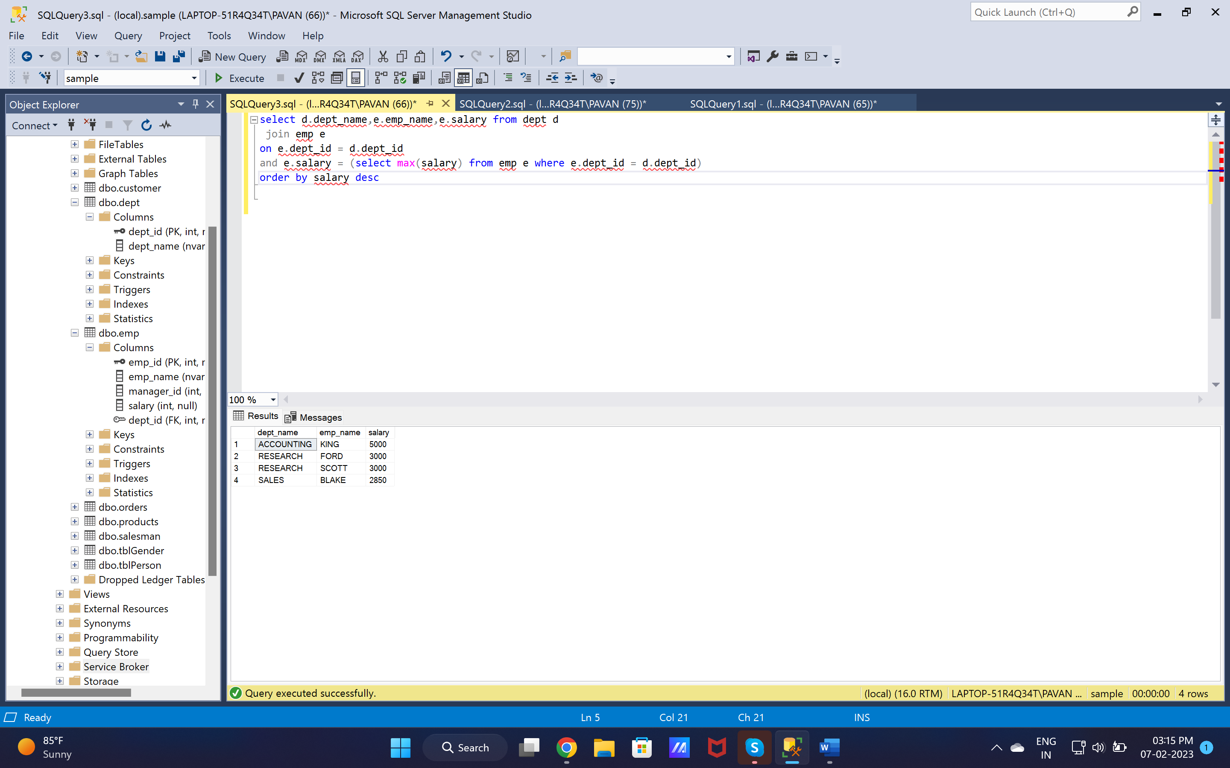

1. write a SQL query to find Departments that have less than 3 people in it

select d.dept_name,count(e.dept_id) as No_of_employees from emp e

join dept d

on d.dept_id = e.dept_id

group by d.dept_name

having count(e.dept_id) < 4

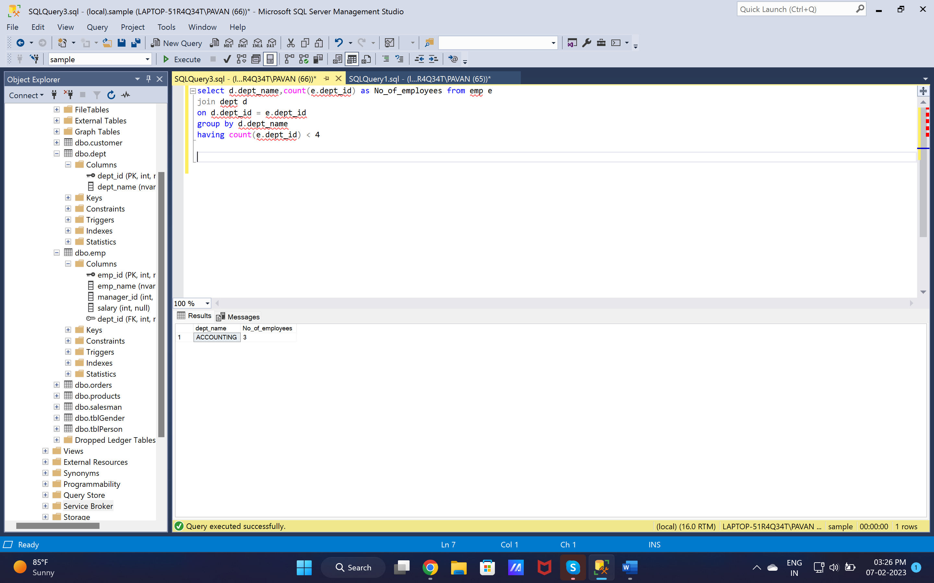

1. write a SQL query to find All Department along with the number of people there

select d.dept_name,count(e.dept_id) as No_of_employees from emp e

right join dept d

on d.dept_id = e.dept_id

group by d.dept_name

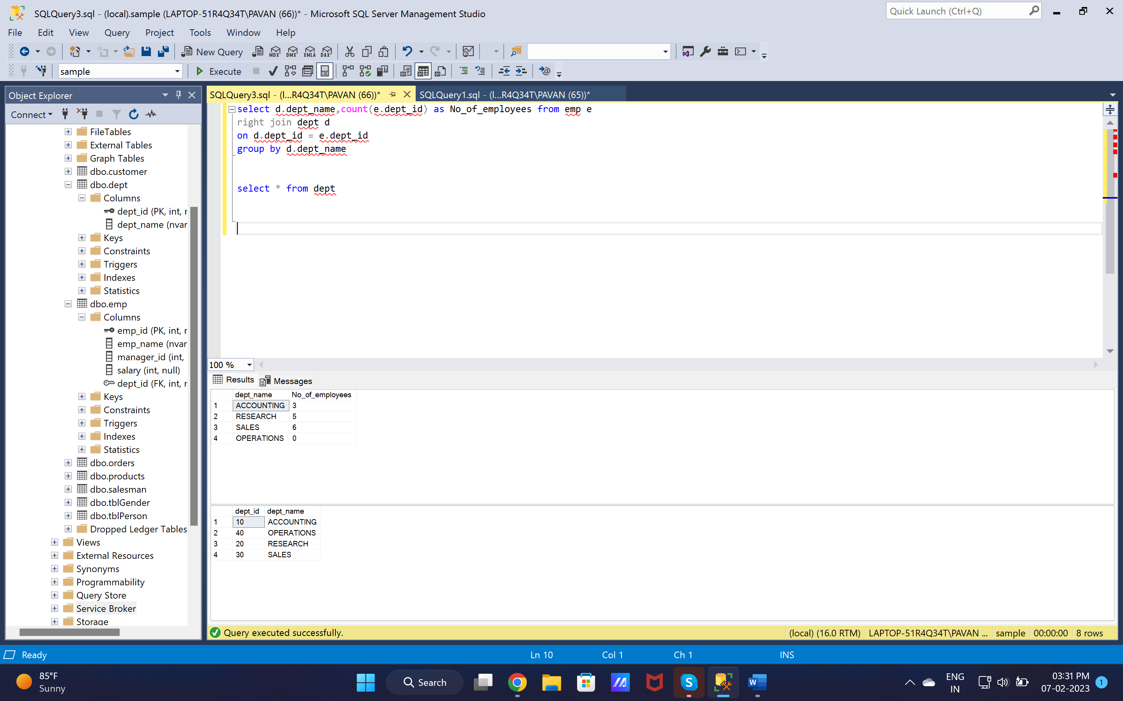

1. write a SQL query to find All Department along with the total salary there

select d.dept_name,sum(e.salary) as Total_depatment_salary from emp e

right join dept d

on d.dept_id = e.dept_id

group by dept_name

order by sum(e.salary) desc

